Topic 7 test
Name:
Score: 14/15
24/35
Time: 60 minutes

- The first 15 questions are multiple choice. Please answer by highlighting A, B, C OR D on the answer sheet provided.
- The second part is the written segment, and you can answer in the spaces provided on this document.
- When complete, upload both the answer sheet and this test to assignments

Part A

Part B
Nutrient | Role in the body
Protein | Cell support/repair
Lactose (sugar in milk) | Turns the sugars into energy
Calcium | Help bone tissues/ build bone tissues
[3]

[3]
Can cause dehydration to the body, loss of blood pressure, kidney failure

[1]
The small intestine moves in waves to push the fooduses muscles

P-epithelium
Q-capillary
R- lacteal
[3]

Hepatic portal vein
[1]

[2] 1
To increase surface area and absorb more nutrients

1 [3]1
Mechanical digestion is physically breaking the food (teeth), chemical digestion is to break down the food using enzymes and acids

a.(i) Describe the role of bile in digestion [2]
Bile breaks down fats into fatty acids and to carry away waste from the liver

Function | Name of part | Letter from Fig. 5.1
Produces bile | Liver | J
Most soluble food is absorbed into the blood | Small intestine | e
Indigestible food is egested | Large intestine | g
Hydrochloric acid is produced | stomach | c
Protease, lipase and amylase are produced | Pancreas | D
[4] 3
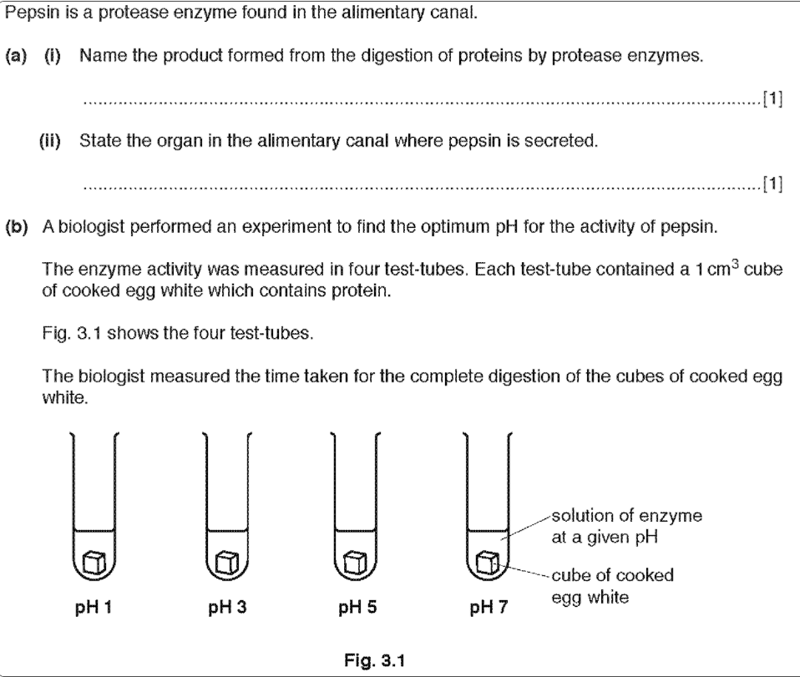
stomach
Amino acids
3
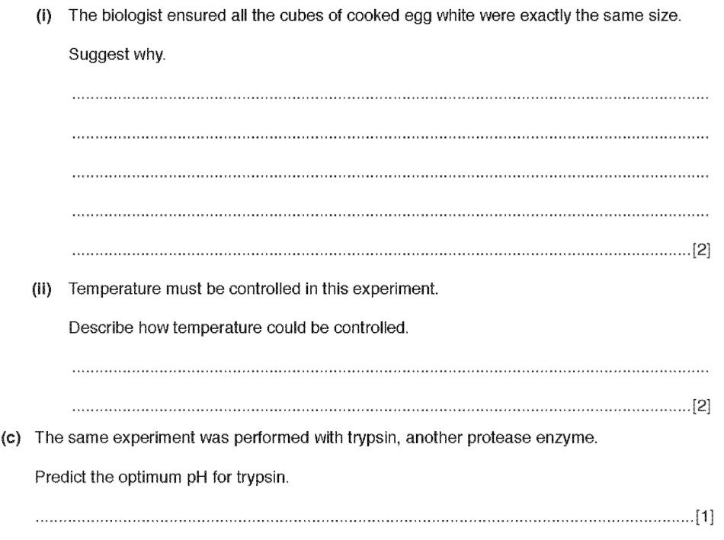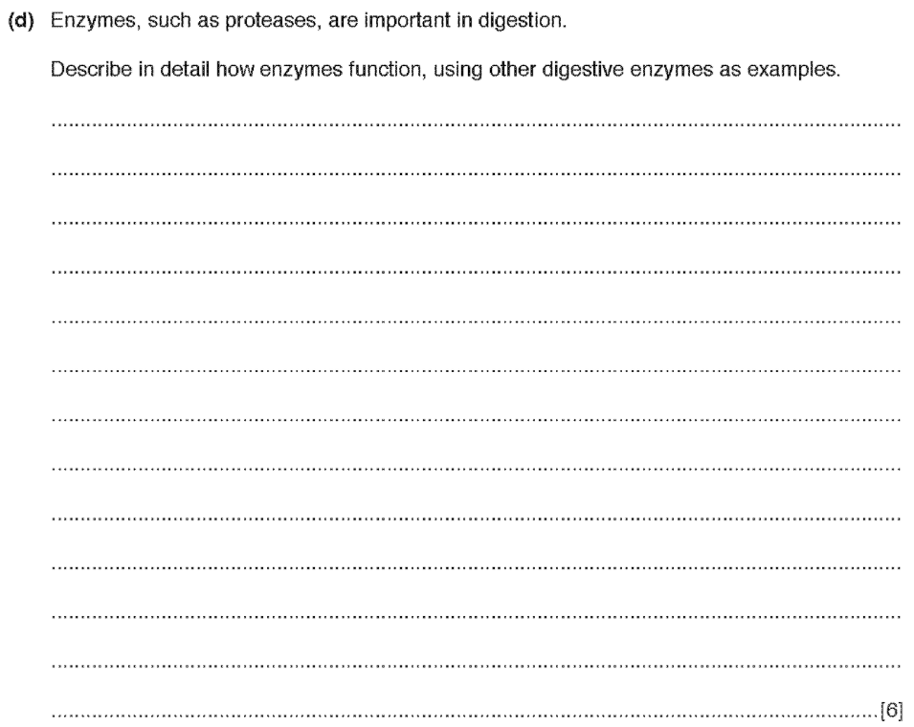
7
By using thermometer, or using an incubator to have a measured water temperature
To control the experiment to minimize the factors affecting the results, and because it affects activity
Enzymes have specific functions, they are catalysts that speed up reactions, they lower activation energy to help reactions, they break down insoluble molecules, they have an optimum PH and temperature and if they pass it they can denature which will stop their functionality, they are made from protein.

